Technical Documentation: Google Gemini AI Hardware Advisor & Semantic Search Implementation

1. Feature Overview & Architecture
The AI Hardware Advisor is an intelligent assistant integrated into the Jenga Marketplace platform. It combines Large Language Models (LLMs) with Retrieval-Augmented Generation (RAG) and semantic vector search to provide tailored hardware recommendations, DIY troubleshooting, and construction material estimations directly linked to active seller inventory.
Key Capabilities
- Conversational Hardware Consultation: Answers DIY, repair, and construction queries in real time using high-speed language processing.
- Semantic Catalog Retrieval (RAG): Transforms user inquiries into high-dimensional vector embeddings, matches them against indexed catalog products via vector cosine similarity, and injects live inventory context into the model's prompt.
- Failover Hybrid Search: Automatically falls back to keyword-based multi-attribute scanning if embedding rate limits or API throttles are encountered.
- Decoupled Data Serialization: Utilizes flat Data Transfer Objects (DTOs) to safely isolate relational database entities from API response payloads, preventing circular recursion and payload bloat.

2. Project Folder Structure
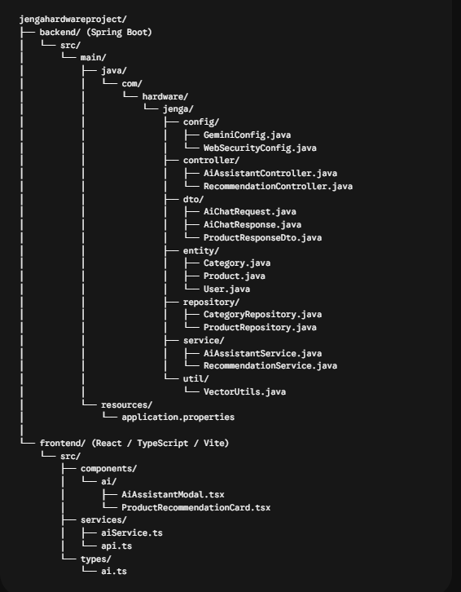

3. Backend Components & Responsibilities
Configuration Layer (config/)
- GeminiConfig.java: Configures the foundational LangChain4j beans for Google AI. Sets up the primary chat model connection for language generation and the embedding model connection for vectorization, dynamically loading credentials from application properties and environment variables.
- WebSecurityConfig.java: Manages endpoint security, CORS filters, and route permissions to allow authenticated chat interactions while protecting administrative routes.
Controller Layer (controller/)
- AiAssistantController.java: Exposes the primary conversational REST endpoint (/api/ai/chat), accepting validated user prompts and returning structured assistant advice along with associated catalog products.
- RecommendationController.java: Exposes dedicated vector similarity endpoints for direct product-to-product recommendations and catalog search.
Data Transfer Layer (dto/)
- AiChatRequest.java: Encapsulates incoming user message payloads.
- AiChatResponse.java: Defines the structured output returned to the client, containing the textual assistant reply and a sanitized list of recommended product DTOs.
- ProductResponseDto.java: Flattens and decouples relational database entities (handling nested relationships such as Categories and Sellers) into pure data records to eliminate JSON serialization recursion.
Service Layer (service/)
- AiAssistantService.java: Coordinates the RAG pipeline. It takes the incoming query, delegates vector retrieval to find relevant products, structures an instruction prompt loaded with live catalog context, triggers the chat model generation, converts products to clean DTOs, and compiles the final response.
- RecommendationService.java: Handles vector math, text-to-vector embedding generation, semantic cosine similarity calculations, on-demand embedding persistence, and resilient fallback search when external vector quotas are restricted.
Utility & Data Layer (util/, entity/, repository/)
- VectorUtils.java: Provides mathematical vector operations such as dot product calculation, Euclidean norms, and cosine similarity matching.
- ProductRepository.java: Facilitates database operations and filtered querying for items containing valid embedding data.
4. Frontend Components & Responsibilities
Service Layer (services/)
- api.ts: Centralized Axios client instance configured with backend routing, token management, dynamic environment base URLs, and global error interceptors.
- aiService.ts: Dedicated service for dispatching asynchronous chat requests to the backend AI controller and managing timeout handling.
Presentation Layer (components/ai/)
- AiAssistantModal.tsx: Interactive chat interface featuring message history, real-time loading indicators, user input submission, and structured rendering for both text advice and catalog recommendations.
- ProductRecommendationCard.tsx: Specialized UI component that displays recommended hardware items, pricing in local currency, stock indicators, and direct seller contact links.
5. End-to-End Data Flow
- User Interaction: The customer opens the assistant modal and submits a project or repair inquiry.
- Semantic Matching: The backend passes the text to the Google AI Embedding API to generate a vector representation of the query.
- Inventory Ranking: The server compares the query vector against stored product vectors in the database, ranking items by cosine similarity.
- Context Injection (RAG): Top matching products are injected into a structured hardware advisor prompt containing real-time product titles, descriptions, and pricing.
- Model Inference: The chat model evaluates the prompt with the embedded catalog context and generates tailored guidance.
- DTO Transformation & Delivery: The generated advice and mapped product DTOs are bundled and returned via JSON to the frontend interface for immediate rendering.

